Software Design Document (SDD)
FinRAG Platform
Author: Kayla Sermini
Stack: Python (FastAPI), React, PostgreSQL, ChromaDB, LangGraph, OpenAI API
Type: Portfolio | FinTech | Full-Stack AI Engineering | RAG Systems

1. Introduction

1.1 Purpose
The FinRAG Platform is an internal-facing, full-stack Retrieval-Augmented Generation (RAG) system purpose-built for AI engineering, compliance, and operational observability in financial environments. While it originated as a portfolio demonstration of GenAI and RAG system architecture, its expanded mission is to act as an internal control center for monitoring LLM usage, vector retrieval patterns, system bottlenecks, and business-critical metadata.
The primary goal is to equip AI engineers, data leads, and platform administrators with insights into system behavior, performance, and cost implications, enabling better resource allocation, compliance alignment, and innovation prioritization. Think of it as the “mission control” of financial LLM applications.

1.2 Scope
The platform supports:
- Ingestion of financial documents and structured data
- Embedding-based vector search and retrieval
- Real-time LLM response generation via OpenAI or Claude
- Role-Based Access Control (RBAC) for users and admin tools
- Visual Admin Portal that:
  - Surfaces logs, latency, usage spikes
  - Shows metadata (cached, token cost, source)
  - Offers API and audit trail explorers
- Operational monitoring including CPU load, memory, and query throughput
- Scalable architecture with modular backend services
- Future-facing design to support:
- Feedback loops for LLM fine-tuning
- Plugin support (e.g., financial calculators)
- Self-healing logs and CI/CD integrations
Future enhancements include multi-agent reasoning, audit trail integration, and continuous feedback loops for LLM fine-tuning.

2. Architecture

2.1 High-Level Overview
The architecture is modular, horizontally scalable, and optimized for financial document handling. It follows a service-oriented structure with strict separation between front-end, back-end, vector search, and inference services.
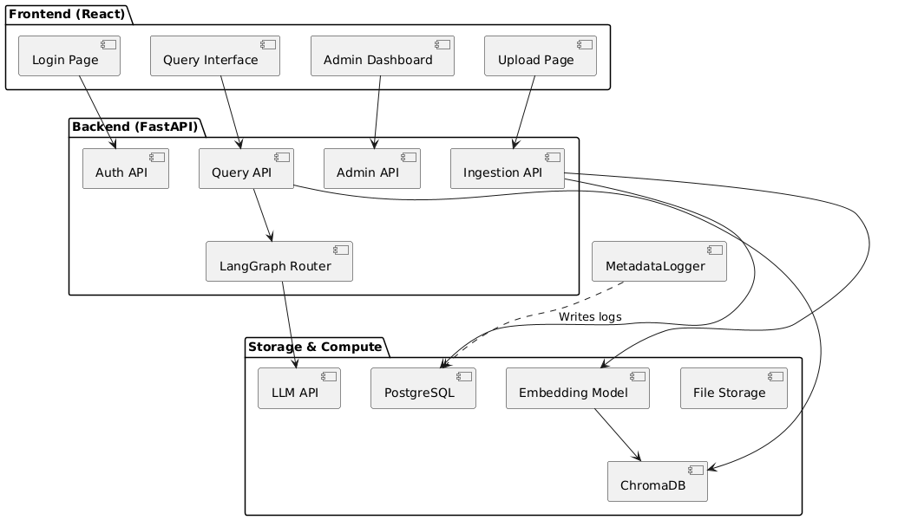

2.2 Component Diagram
Frontend (React + Tailwind)
- Login Page
- Query Interface
- Admin Dashboard
- Document Upload Page
- Role-Based Views
Backend (FastAPI)
- Auth API (/auth/*)
- Query API (/query)
- Ingestion API (/upload, /embed)
- Admin API (/admin/*)
- LangGraph LLM Router
Admin Dashboard Layer (New Emphasis):
- Role-based visibility into system metrics
- Dynamic visualization of token usage, latency, cache rates
- Drill-down panels for audit logs, error rates, and ingestion bottlenecks
Operational Metadata Layer:
- Tracks performance by user, model, endpoint
- Logs ingestion metadata (file size, ingestion latency, chunking rate)
- Integrates cached vs uncached query tracking

Storage & Compute
- Vector Store: ChromaDB
- Embedding: OpenAI Ada / SentenceTransformers
- LLM: OpenAI GPT-4, Claude v2
- Metadata DB: PostgreSQL
- File Storage: Local or S3

3. Class Design
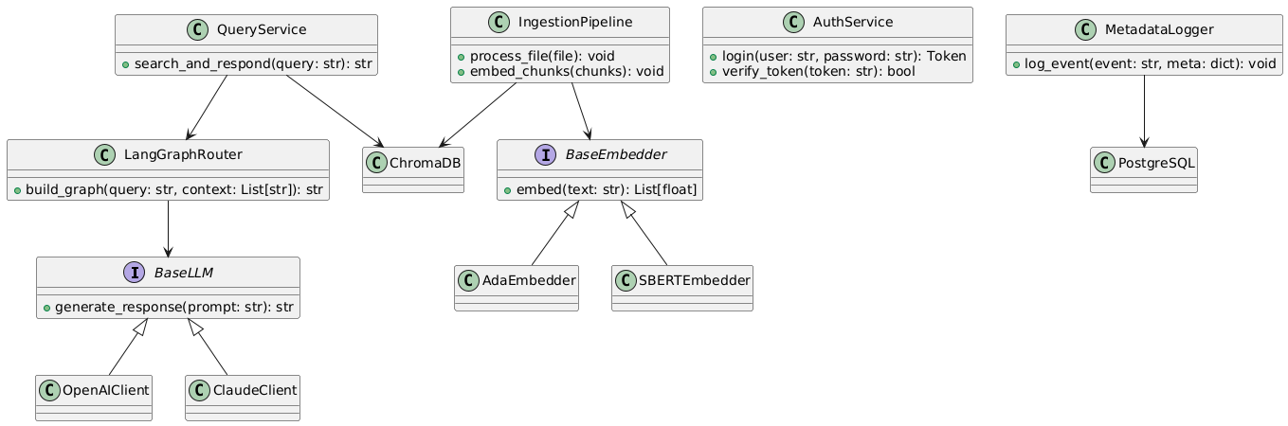

3.1 Class Responsibilities
Class/Module | Role
AuthService | Handles login, token creation, session management
QueryService | Interfaces with ChromaDB and LLM pipeline
IngestionPipeline | Parses, chunks, and embeds documents
LangGraphRouter | Dynamically assembles RAG flow nodes
VectorDBClient | Abstracts vector DB operations
MetadataLogger | Records user interactions and performance metrics
AdminService | Controls ingestion, user creation, and dashboard stats

Design Principles
- Encapsulation: Each module handles a single concern.
- Open/Closed: New models or vector stores can be added via config.
- Dependency Inversion: LLM and vector store interfaces are abstracted.
- Polymorphism: BaseLLM and BaseEmbedder interfaces enable interchangeable AI models.

4. Execution Flow

4.1 Sequence Diagram – RAG Query
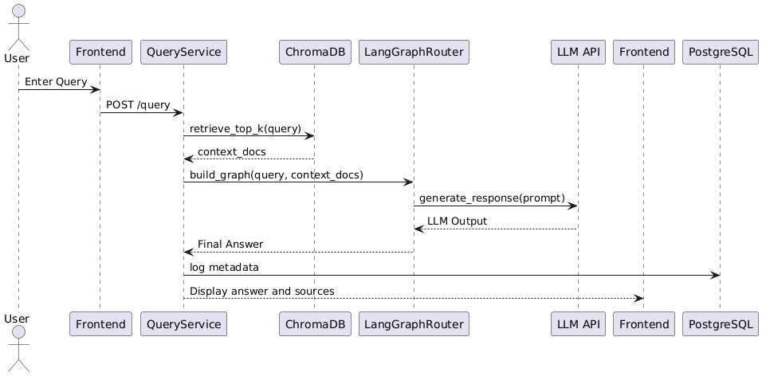

Step-by-Step
- User inputs a financial query.
- Request hits /query endpoint.
- QueryService retrieves top-k docs from ChromaDB.
- LangGraph router dynamically builds a node graph.
- Context and prompt are passed to the selected LLM.
- Response is returned and logged.
- Frontend displays the answer, metadata, and source documents.
Step-by-Step (Admin-Facing Lens):
- Admin logs in and views real-time dashboard
- System ingests operational metadata into PostgreSQL
- Visual components auto-refresh via API polling
- Drill-downs (e.g., AuditViewer, APILogs) allow inspection of individual entries
- System alerts highlight cache misses, slow queries, and ingestion stalls

5. Design Decisions
Element | Justification
LangGraph | Enables dynamic prompt chaining and multi-step agents
ChromaDB | Lightweight, open-source vector store for quick prototyping
OpenAI/Claude | Industry-standard for RAG applications
PostgreSQL | Strong relational guarantees and JSON support for logs, Flexible for storing rich log data and extending with custom fields
FastAPI | Async performance, typing, and extensibility
React + Tailwind | Clean UX with component reusability
Role-Based Access | Supports enterprise-grade security & feature visibility
Operational Metadata | Enables auditing, monitoring, and observability. Core abstraction for observability layer across RAG flow
Role-Based Views | Admins see full logs, engineers see component status
Real-Time UI | Enables engineering awareness of latency, cost, and load

6. Prompt Engineering Strategy
All prompt executions are logged with latency, token usage, and metadata such as:
- Model used
- Query category
- Retrieved documents (with confidence and rank)
- Cached status (to track performance optimizations)
These enable correlation between prompt structure and system efficiency.
- System prompt templates are dynamically constructed.
- User input is cleaned, rewritten, and contextualized with retrieved docs.
- Metadata includes: source confidence, retrieval rank, and token usage.

Prompt Format Example:

System: "You are a financial assistant..."
User: "What are the liquidity ratios for JPMorgan in 2023?"
Context: [Doc1], [Doc2], ...
Final Prompt → LLM

7. Usage

7.1 Input Parameters
- Query: Free-text question from user
- User role: Controls visibility and logging
- LLM: Specified in config (openai, claude, etc.)
- Retrieval k: Top k results from vector DB

7.2 Ingestion Pipeline
- Admin uploads PDF.
- Document is split (chunk size configurable).
- Embeddings are created and stored in ChromaDB.
- Metadata is logged to PostgreSQL.

7.3 Output
- LLM response
- Source documents used
- Response metadata (latency, tokens, rank, timestamp)

8. Build Instructions

8.1 Tools Required
- Python 3.10+
- Node 18+
- PostgreSQL 15+
- ChromaDB
- OpenAI/Anthropic API Key

8.2 Backend
cd backend/
python -m venv venv
source venv/bin/activate
pip install -r requirements.txt
uvicorn main:app --reload

8.3 Frontend
cd frontend/
npm install
npm run dev

8.4 Clean
find . -name "__pycache__" -exec rm -r {} +

9. Future Enhancements
Feature | Description
Feedback Loop | User thumbs-up/down to improve RAG quality
Multi-agent Routing | LangGraph to handle clarifying questions
CI/CD | GitHub Actions for deployment and versioning
Observability UI | Frontend dashboard for logs, errors, token stats
Fine-tuning Pipeline | Triggered by user feedback
Plugin Support | Add calculators, real-time stock queries
Self-Healing Logging | Sync fallback logs with main DB

10. Conclusion
This project reflects real-world GenAI system complexity with a modular, production-ready design. It demonstrates architectural mastery in retrieval, prompt chaining, vector search, and LLM integration for the financial domain. The RAG engine is not only performant and cleanly engineered, but it’s built to scale, adapt, and continuously improve with user input.

